

**MARMARA UNIVERSITY**

**FACULTY OF ENGINEERING**

**COMPUTER PROGRAMMING 2**

**CSE 1242.1.0**

**SPRING 2022**

**TILE GAME PROJECT**

Due Date: 09.05.2022

|  |  |  |
| --- | --- | --- |
| Authors | Name | ID |
| 1 | Kadir Bat | 150120012 |
| 2 | Feyzullah Asıllıoğlu | 150121021 |

1-) Problem Definition

This a tile game. It consists of 6 levels in total. The game starts when you press the play button. The game also counts how many moves you have made. There are tiles with many different features. Some cannot move. Some are empty. some tiles have pipes. These are pipe tiles. They can be vertical, horizontal or curved.

There are 16 tiles in total. Starter and end tiles cannot be moved because they are static. The aim of the game is to get the ball from the starting tile (blue) to the finishing tile (red). You have to deliver the ball by making moves. It is important to pass the level in the fewest moves.

2-) Implementation Details

1. i) In this project the last level is not working and animation is a little bit broken.
2. ii) Animation part was very hard.

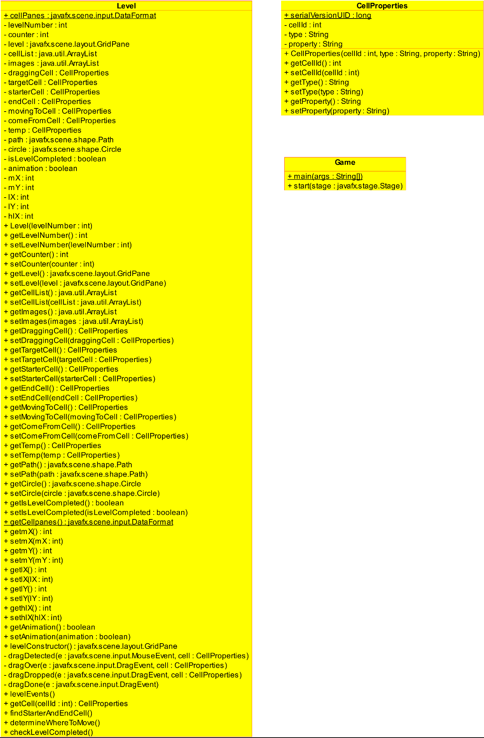

3-) Explanation of UML Diagrams

Cell Properties class

cellId : id number of the cell

type : specifies the property of tiles

property : specifies the property of tiles ( none, Vertical, Horizontal...)

CellProperties(cellid : int, type: String, property : String) : Constructor of class

getCellId : getter method of cellId

setCellId : setter method of cellId

getType : getter method of type

setType : setter method of type

getProperty : getter method of property

setProperty : setter method of property

Game Class

main : main method

start : This method creates the panel. We created stage and scene using the classes we imported. We use BorderPane, StackPane, Label, Button, Scene and Stage

Level Class

cellPanes : reads “Cell’s on the grid pane”

levelNumber : indicates number of the level

counter : It counts the moves made

level : it is about GridPane class

cellList : it is an ArrayList. This list contains cells.

images : it is an ArrayList. This list contains images.

draggingCell : This is a cell that is dragged cell.

targetCell : This is the cell to be moved.

starterCell : It is the starting cell of that level. It is colored blue. It cannot move.

endCell : It is the end cell of the level. It is colored red and it cannot move.

movingToCell : This is the movement of a cell.

comeFromCell : defines movement from that cell

temp : used to change values.

path : it is an object. It is effective in cell movement and it is obtained by using the path class.

circle : It is obtained by using the Circle class. It makes a circle.

isLevelCompleted : it has a boolean value. It may be true or false. It indicates the level is completed or not.

animation : it has a boolean value. It may be true or false. It checks animation state.

mX : it indicates the coordinates.

mY : it indicates the coordinates.

lX : it indicates the coordinates.

lY : it indicates the coordinates.

hlX : it indicates the coordinates.

Level(levelNumber : int) : Constructor of Level class.

getLevelNumber : getter method of levelNumber

setLevelNumber : setter method of levelNumber

getCounter : getter method of counter

setCounter : setter method of counter

getLevel : getter method of level

setLevel : setter method of level

getCellList : getter method of cellList

setCellList : setter method of cellList

getImages : getter method of images

setImages : setter method of images

getDraggingCell : getter method of draggingCell

setDraggingCell : setter method of draggingCell

getTargetCell : getter method of targetCell

setTargetCell : setter method of targetCell

getStarterCell : getter method of starterCell

setStarterCell : setter method of starterCell

getEndCell : getter method of endCell

setEndCell : setter method of endCell

getMovingToCell : getter method of movingToCell

setMovingToCell : setter method of movingToCell

getComeFromCell : getter method of comeFromCell

setComeFromCell : setter method of comeFromCell

getTemp : getter method of temp

setTemp : setter method of temp

getPath : getter method of path

setPath : setter method of path

getCircle : getter method of circle

setCircle : setter method of circle

getIsLevelCompleted : getter method of isLevelCompleted

setIsLevelCompleted : setter method of isLevelCompleted

getCellpanes : getter method of cellPanes

getmX : getter method of mX

setmX : setter method of mX

getmY : getter method of mY

setmY : setter method of mY

getlX : getter method of lX

setlX : setter method of lX

getlY : getter method of lY

setlY : setter method of lY

gethlX : getter method of hlX

sethlX : setter method of hlX

getAnimation : getter method of animation

setAnimation : setter method of animation

levelConstructor : Constructor of each level

dragDetected : Dragging steps

dragOver : Dragging steps

dragDropped : Dragging steps

dragDone : Dragging steps

levelEvents : works the same as its name

getCell : getter method of cellId

findStarterAndEndCell : works the same as its name

determineWhereToMove : works the same as its name

checkLevelCompleted : checks the level that is completed or not.

Test Cases:

Opening Page

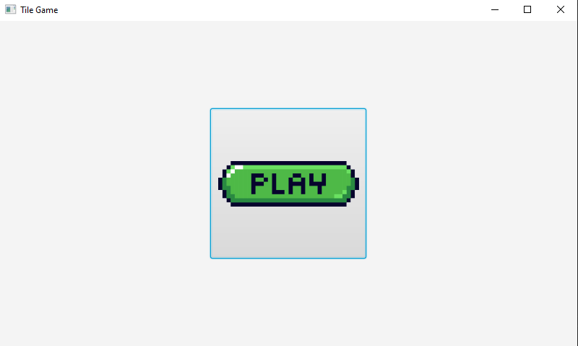

Level 1

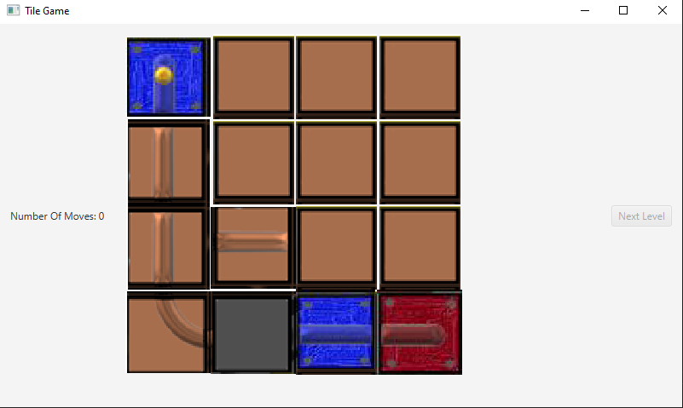

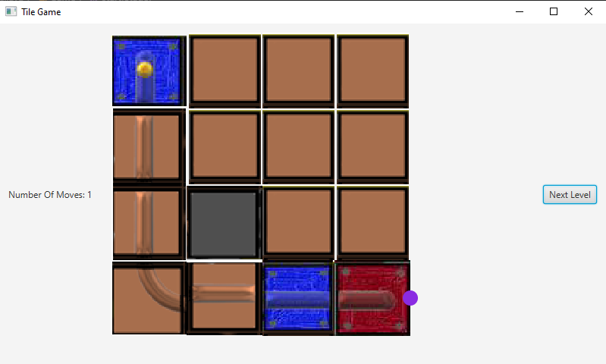

Level 2

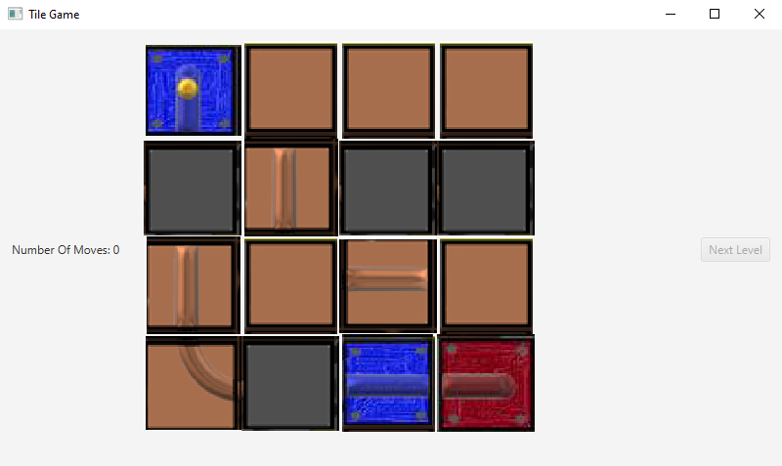

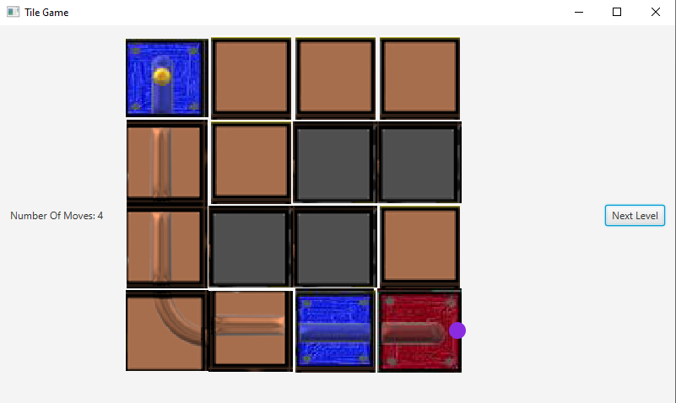

Level 3

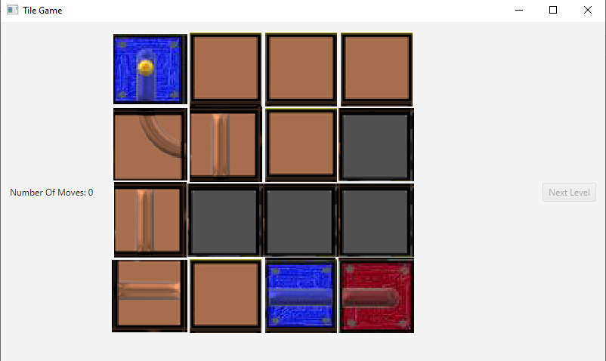

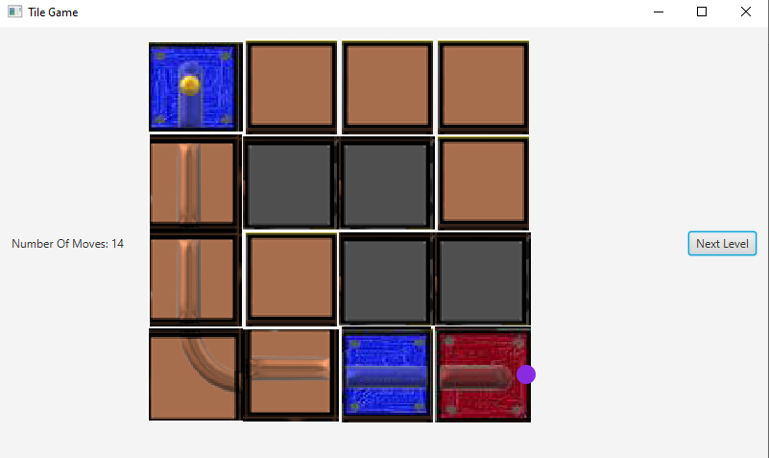

Level 4

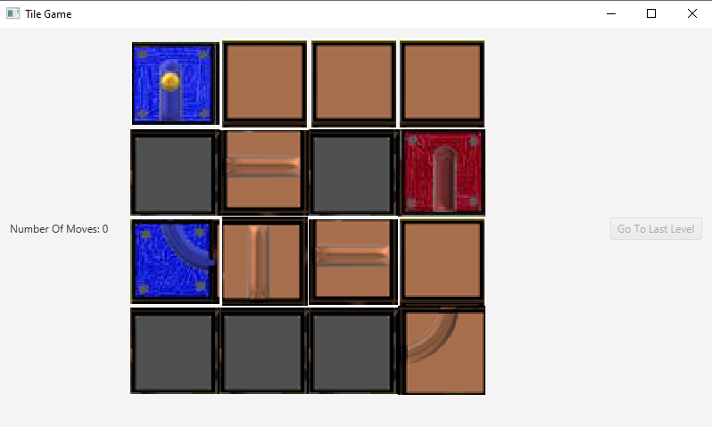

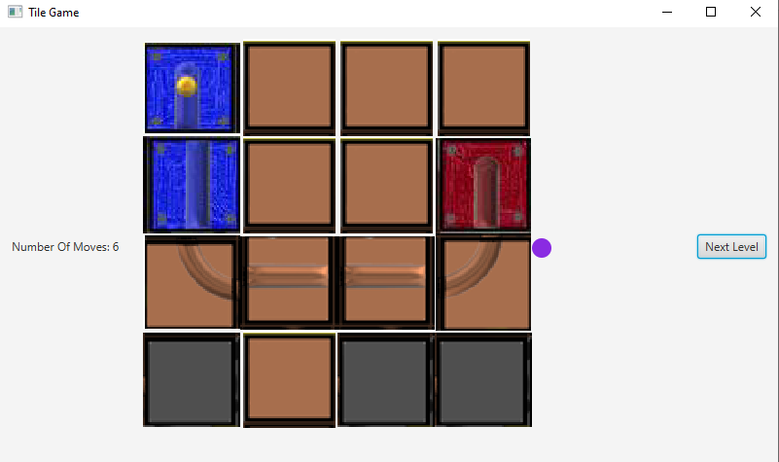

Level 5

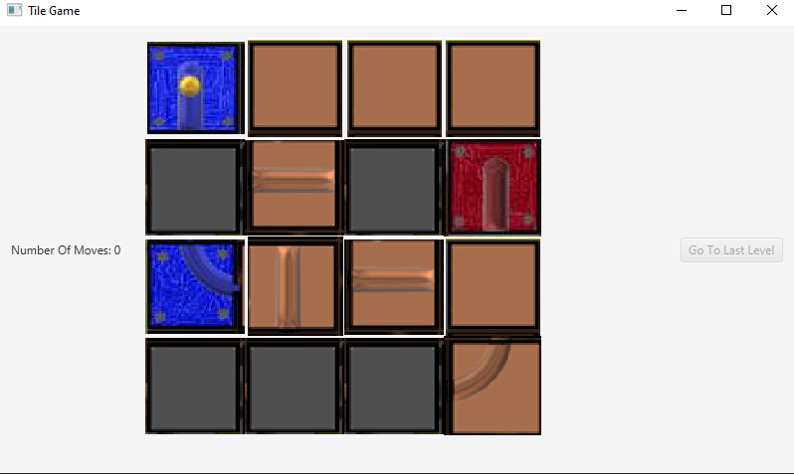

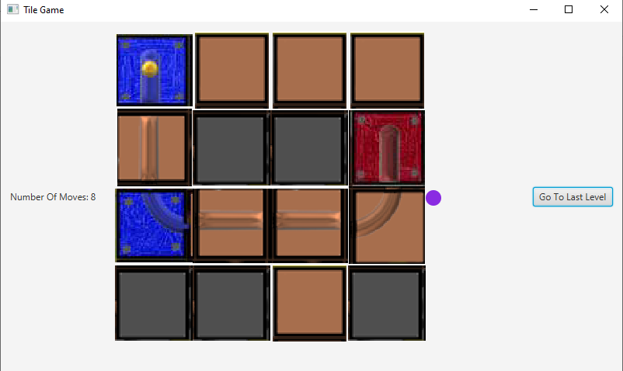

Level 6 (not working)

